

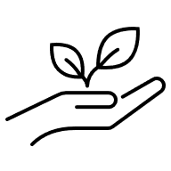



**You can talk to** at the village hall if you have any comments, questions or suggestions as to how the hall can help with the **5 Ways to Wellbeing.**

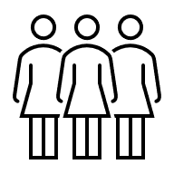

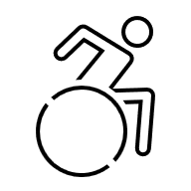

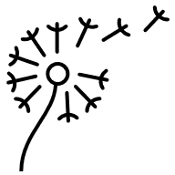

**Connect - Build strong relationships with the people around you.**

**C**all or message someone you care about. **M**ake time to chat with people,

**J**oin a club, group or activity that you enjoy.

**Be Active -**  **Physical activity is great for your body and mind.**

**M**ove more, sit still less. **M**ove in a way that makes your heart beat faster

**D**o something active that you like doing.

**Take Notice - Be curious. Catch sight of the beautiful. Notice the changing seasons.**

**P**ractice mindfulness. **S**pend time in nature. Make a note what you are grateful for.

**Keep Learning - Learning new things boosts self-confidence and keeps your brain active.**

**T**ake up a new hobby. **R**ead, or listen to a new book, **A**ttend a workshop or class.

**Give - Giving creates connections and a sense of purpose.**

**H**elp someone out. **G**ive someone a smile. **V**olunteer your time or skills.

The **Five Ways to Wellbeing**, developed by the New Economics Foundation are widely accepted as actions that can protect and improve both mental and physical health and well-being. Here are a few ideas to try: